3-6 Months Fuzzy Trim Winter Boots
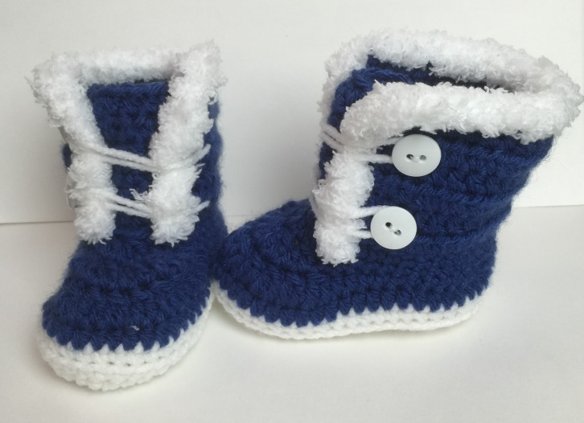

Material:
Lion Brand Vanna’s Choice – Colonial Blue
Red Heart love – White
Fuzzy/ Fur Yarn – I’m sorry, I’m not sure of the name
(4) Buttons of your choice
Tapestry Needle
Size Hook: F

Abbreviations:
SL ST= Slip Stitch
STS = Stitches
CH = Chain
SC= Single Crochet
Hdc = Half Double Crochet
DC = Double Crochet
DC2Tog = Double Crochet 2 together

SOLE: Measures 4” depending on how tight you crochet
Chain 11
Round 1: Make 2 HDC into the 2nd chain from hook, Hdc 8, Make 6 Hdc into the last Chain (Now working on other side of chain), Hdc 8, make 2 Hdc in to the last chain, Join with a sl st, Ch 1 (26)
Round 2: Make 2 Sc into the same st as ch 1, 2 Sc, Sc 8, Hdc, 2 Hdc into the next 5 sts, Hdc, Sc into the next 8, 2 Sc into the last 2 sc, join with a sl st, Ch 1 (36)
Round 3: Hdc into same ch 1, 2 Hdc, Hdc, 2 Hdc, Hdc 9, (2 Hdc, 1 Hdc) 6 times, Hdc 8, (2 Hdc, 1 Hdc) into last 4 sts, join with a sl st, ch 1 (47)
Round 4: Work Sc all around and join with a sl st (48)
Round 5: Working in back loops only, Sc all around and join with a sl st, Ch 1 (48)
*Do not fasten off* Change colors
Round 6: Hdc all around and join with a sl st, Ch 1 (48)
Round 7: Sc into same st as ch 1, Sc, Sc2tog, Sc 8, Hdc 2, Dc2tog 10 times, Hdc 2, Sc 8, Sc2tog, Sc 2, join with a sl st and ch 1 (36)
Round 8: Sc into same st as ch 1, Sc 11, Hdc 2 , Dc2tog 4 times, Hdc 2, Sc 12, join with a sl st, ch 1 (32)
Round 9: Make Sc into same st as ch 1, Sc 10, Hdc 2, Dc2tog 3 times, Hdc 2, Sc 11, join with a sl st and Fasten off and weave in ends (29)

FRONT FLAP OF BOOT:
*With toe facing away from you*
Count 6 sts back from middle of toe
Attach yarn in back loop and working in back loop only
Row 1: SC 12 sts working towards the front of shoe, Ch 1, turn (12)
Row 2-7: Hdc across, on last row, tie off and weave in ends (12)

BACK & BODY OF BOOT:
*With toe facing away from you*
Count 4 sts forward from where your front flap ends
Attach yarn in front loop and working in front loop only
**You will work in front loops until you can work in both loops, same for when you get to other side. Stop working when you are 4 sts from beginning of front flap**
Row 1: Sc as stated above
Row 2-7: Hdc across, on last row, tie off and weave in ends

BORDER:
With fuzzy yarn, Sc around Back Part of boot

CLOSURE:
Cut a piece of yarn that you fold in half and is long enough that goes from one side to the other and will be slightly tight around button. (Mine was about 14” long)
Tie end with 2 strands in a knot. Insert each strand separate into inside of boot and weave in ends
Attach buttons on opposite side.
*Repeat the same process for other boot on opposite side

I have made a video on how to make these on Youtube for help:
Youtube Link: https://youtu.be/NoQ6VdyilkM

All Done!
I hope you enjoy it. If you have any questions, don’t hesitate to ask.
KittysKreationsBoutique@Gmail.com
Instagram: KittysKreationsBoutique (Follow me for latest items up for sale & discount codes for my Etsy shop)
Etsy: KittysKreationsB
Facebook: Kitty's Kreations Boutique (Like my page for all the latest items up for sale and videos being posted)
Youtube: Kitty’s kreations Boutique (Subscribe for fun videos from cooking to crochet)

Thank you again
Kat

